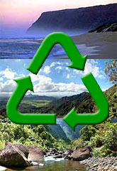 | Aloha, West Shore Visitors . . .  Please Help Us Keep the  Garden Island Green!  Using this guide, you can help conserve Kaua‘i’s landfill space.  Mahalo for recycling while you’re here!

What can be recycled | Where you can take it
Under the Bottle Bill law, you can return HI5 beverages and receive payment based upon the weight of your beverage containers.  5¢ Deposit Containers include:  Aluminum cans, Plastic & Glass beverage bottles  Containers must be marked Hawaii 5¢ or HI 5¢ – water, soda, beer, juice, tea/coffee/sport drinks, etc  When recycling at a redemption center:  *No liquid, cigarettes or trash. (A quick rinse is much appreciated!)  *Remove tops.  *Maximum size is 68 ounces  (2 liters).  *Labels are required to get deposit back.  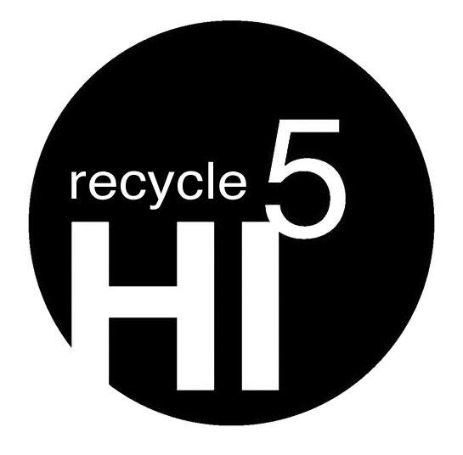  *Wine & liquor bottles are not accepted. | Redemption location on the West Side:  Kaua‘i Community Recycling Services  Kekaha Rd. located across from the Old Sugar Mill in Kekaha  Open Wednesdays & Saturdays  from 8 am -4 pm  (808) 645-1676  OR bring them to:  Kaua‘i Recycles Drop Bins in  Hanapēpē, Waimea, and Kekaha  There you’ll find separate bins for each type of material. Thanks for sorting them!  Located at 4380 Lele Rd. in front of the Hanapēpē Refuse Transfer Station  Available 24 hours a day, 7 days a week.  OR  Located at Waimea Athletic Field  Available 24 hours a day, 7 days a week.  OR  Located at 6900-D Kaumuali‘i Hwy. at the Kekaha Landfill  Open daily from 8 am – 4 pm closed from  12 pm -12:30 pm except on State holidays.    For more information call the  County Recycling Office at 241-4841  www.kauai.gov/recycling

Aloha, West Shore Visitors . . .
Please Help Us Keep the
Garden Island Green!

Using this guide, you can help conserve Kaua‘i’s landfill space.
Mahalo for recycling while you’re here!

What can be recycled | Where you can take it
FOR REDEMPTION  Get 5¢ back when you recycle  Aluminum cans  Plastic & Glass beverage bottles that are containers marked Hawaii 5¢ or HI 5¢ – water, soda, beer, juice, tea/coffee/sport drinks, etc.  Tips to follow when at the redemption centers:  No liquid, cigarettes or trash. (A quick rinse is much appreciated!)  Remove tops.  Maximum size is 68 ounces (2 liters).  Labels are required to get deposit back.  Beer bottles & cans are ok, but wine & liquor bottles are not. | You’ll find our on-site HI 5¢ deposit recycling bin: (see box checked below)  in your unit.  outside the house.  by the trash dumpster.  in the guest laundry area.  See attached flyer for information on locations to redeem HI5 bottles/cans and general recycling locations.
PLEASE RECYCLE:  MIXED PAPER (INLCUDES NEWSPAPER)  OK: Magazines, cereal-type boxes, junk mail, window envelopes, white & colored paper, soda/juice boxes, and glossy inserts  NO: milk/dairy or other coated cartons, paper towels & napkins, photos, wet/food-contaminated paper, bags, bundles, or wet paper.  GLASS  Wine & liquor bottles, empty food jars (rinse first)  labels are ok, but remove lids  NO: tops, corks, light bulbs, ceramics  PLASTIC #1 & 2 Bottles & Jars  OK: empty, rinsed bottles and jars with #1 or #2 on the bottom  NO: trays, clamshells, tops, black plastic & plastic 5 gall. Or over.  ALUMINUM & STEEL CANS  OK: Aluminum foil, pie & food pans. Bi-metal and steel food cans (soup, vegetable and pet food cans)  NO: aerosol & paint cans, window frames  CARDBOARD  OK: corrugated boxes. NO: cereal-type or waxed boxes, tape | Take recyclables to the:  Kaua‘i Recycles Drop Bins  Located at: Waimea Athletic Field,  6900-D Kaumuali‘i Hwy. at the Kekaha Landfill or 4380 Lele Rd. at the Hanapēpē Refuse  Transfer Station  

